Colégio Nunes Moraes
Dedicação e Compromisso
TURMA:
8º ANO EF.
NOME:
ATIVIDADE DOMICILIAR DE INGLÊS

A / B

01. Read the text:
a) Escreva, em inglês, um texto similar sobre um ídolo, grupo ou pessoa famosa que você tenha admiração.
________________________________________________________________________________________
________________________________________________________________________________________
________________________________________________________________________________________
________________________________________________________________________________________

Now United is a global pop
music group from different
nationalities. The group
consists 13 members.

02. What’s the difference between a hero, an idol and a role model?

- role model ( ) a person who you admire or adore.
- idol ( ) a courageous person with good acts.
- hero ( ) a person who inspires others as a good example to follow.

03. Link the words and definitions:

Famous ● ● the achievement of desired results.
Performer ● ● a special natural ability to do something well.
Talent ● ● a person who acts, sing, dance or play music.
Success ● ● known and recognized by many people.

04. Read the text:

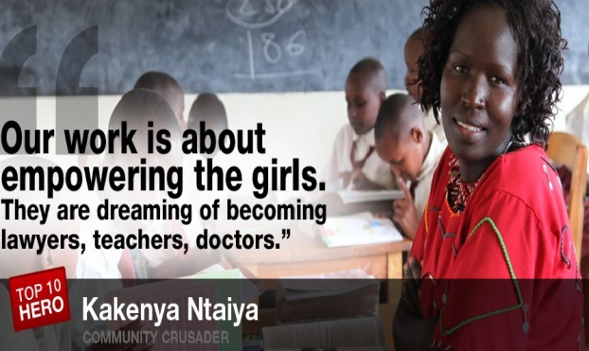
Kakenya Ntaiya: Educating girls for the first time

Kakenya Ntaiya is inspiring change in her native Kenyan village. After becoming the first woman in the village to attend college in the United States, she returned to open the village's first primary school for girls. "Our work is about empowering the girls," Ntaiya said. "They are dreaming of becoming lawyers, teachers, doctors."

a) Write T (True) or F (False) according to the text:
( ) Kakenya became the first woman in her village to go to college.
( ) She opened the first primary school for boys and girls in her village.
( ) Her work is about empowering girls who want to become professionals.
( ) She only wants to give a basic education for the girls.

